User’s guide of MedFDTD

Wang Meng, Yu Dong
Britton Chance Center for Biomedical Photonics
Wuhan National Laboratory for Optoelectronics
Huazhong University of Science and Technology (HUST)
Content

Directory

1. Quick start 3
1.1 Operating environment 3
1.2 Files description 3
1.3 Create a new project 3
1.4 Import model 4
1.5 Create model 4
1.6 Set excitation source 4
1.7 Compile and run 4
2. Features 5
2.1 Available functions 5
2.2 Available excitation sources 5
2.3 Absorbing boundary 5
2.4 Calculate antenna radiation power 5
2.5 Calculate specific absorption rate (SAR) 5
2.6 Coordinate system and units 5
3. Applications 6
3.1 A simple example: point excitation source spread in vacuum 6
3.2 Dipole antenna: simulation and parameters calculation 7
3.3 SAR calculation: a fat exposure to antenna 10
4. File format 13
4.1 User defined source 13
4.2 Store data and model data 13
4.3 Mass averaged SAR 14
5. Parameters 15

1. Quick start

1.1 Operating environment
User need to set up MPICH2-1.4(UNIX and Windows) to establish parallel computing platform, you can download it from following url:
http://www.mcs.anl.gov/research/projects/mpich2/downloads/index.php?s=downloads.
If user needn’t parallel computation, the MPI is not necessary.

1.2 Files description
- "3D_FDTD_DEFINES.h": Includes projects, models, storage path, the length unit, variable, function definition;
- "INITIALIZE_DATA_AND_FILES.h": Initialization files, create / release the array;
- "SETUP.h": calculate FDTD parameters, load the external model, the establishment of an internal model to calculate the PML factor, FDTD factor, load user define wave source;
- "BUILDOBJECTS.h": Create models, including single medium rectangular, antenna;
- "POWERSOURCE.h": Generated wave source;
- "COMPUTE.h": Main calculation function, including the FDTD iteration, PML calculations and Poynting vector calculations；
- "WRITEFIELD.h": Save field data;
- "EXTENSIONS.h": Post-process, such as calculate SAR.

1.3 Create a new project
Go to “3D_FDTD_DEFINES.h”, set “isNewProj” to 1, and modify codes as shown in following picture, if need to calculate radiation, no comment “#define _POYNTING”, if need to calculate sar, no comment “#define _SAR”.
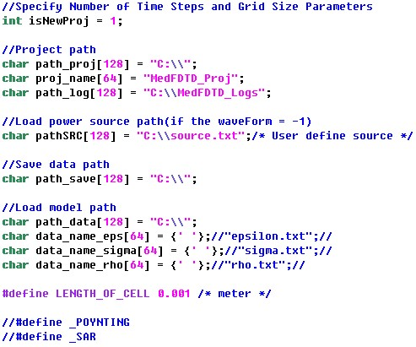
Then go to “3D_FDTD.cpp”, function “newProject”, set parameters from ”/*START*/” to ”/*END*/”. If you have a project file, set “isNewProj” to 0, and operation on function “newProject” can skip.

1.4 Import model
Go to “3D_FDTD_DEFINES.h”, find “//Load model path”, fill the path of model files, if no model, just leave it blank.

1.5 Create model
Go to “3D_FDTD.cpp”, find function “buildObject”, add code such as, buildCuboid, creatDipoleAntenna, create model will coverage the import model if they are in the same space.

1.6 Set excitation source
Available excitation source type include point excitation source and plane wave excitation source, and various waveforms are supported, you also can import a user defined excitation source by set the path of excitation source file in “3D_FDTD_DEFINES.h”.

1.7 Compile and run
User can compile the software by a GNU standard compilers, such as g++. It is noteworthy that the mpi header file “mpi.h” and “mpio.h” is different in windows and linux, so we provide two version for download. After compilation, please open MPICH2, load the MedFDTD file, run.
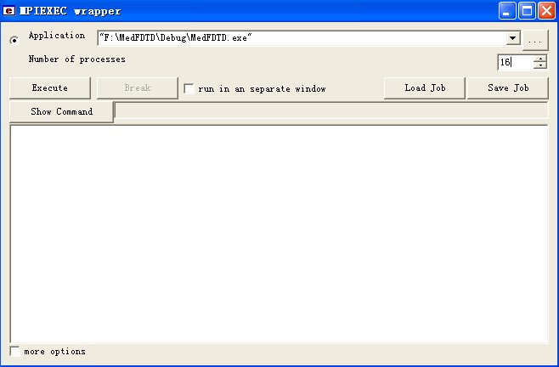

2. Features

2.1 Available functions
By MedFDTD, you can:
- Simulation of electromagnetic radiation, store field data;
- Completely parallel computation;
- Point excitation and plane wave excitation;
- Various absorbing boundary, include PEC, Mur, PML;
- Import model data from hard disk;
- Antenna radiation simulation, calculate radiation power and radiation resistance;
- Calculate Specific Absorption Rate (SAR).

2.2 Available excitation sources
  - Gaussian pulse, parameters: t0---peak position, pulse_width---pulse width;
  - Raised cosine pulse, parameters: pulse_width---pulse width;
  - Derivative Gaussian pulse, parameters: t0---peak position, pulse_width---pulse width;
  - Modulated Gaussian pulse, parameters: freq---modulation frequency, t0---peak position, pulse_width---pulse width.
  - Sine wave, parameters: freq---frequency.

2.3 Absorbing boundary
a) Perfect electronic conductor (PEC)
Set the thickness of PML to 0, the absorbing boundary is PEC, reflect all wave completely.
b) Perfectly matched layer (PML)
Set the thickness of PML to non-zero, the absorbing boundary is PML, absorbing all wave. The compute with PML is time consuming, so recommend set the thickness of PML to 7.
c) Mur absorbing boundary (2-order)
Set the thickness of PML to 0, modify the “main” function, find and replace “compute” to “compute_Mur2”.

2.4 Calculate antenna radiation power
Define “_POYNTING” in “3D_FDTD_DEFINES.h”, then the software will calculate antenna radiation power in post-process.

2.5 Calculate specific absorption rate (SAR)
Define “_SAR” in “3D_FDTD_DEFINES.h”, then you can set SAR calculation in “newProject”. If you need to calculate mass averaged SAR, such as 10 g mass averaged SAR, just “XgSAR = 10;”.

2.6 Coordinate system and units

The coordinate is ranged from 1 to “_spaceX”, “_spaceY” or “_spaceZ”, where “_spaceX”, “_spaceY” or “_spaceZ” means the length of computational space in x, y and z direction. All objects are placed in this coordinate system. In addition, if you import a model, the coordinate system would be determined by the coordinate system of model.

3. Applications

3.1 A simple example: point excitation source spread in vacuum
3.1.1 Set data path
Go to “3D_FDTD_DEFINES.h”, modify the codes as following step:
a) Set “isNewPorj” to 1, then the software will create a new project;
b) Set the path which is used to store project files. In this example, we store them in “D:\”, and the project name is “point”. The log files are stored in “D:\logs\”;
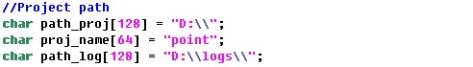
c) Set the path to store field data calculated by MedFDTD, such as E and H field data. In this example, we store them in “D:\”;
d) Set length of cells to 0.001 meter;
e) The radiation power calculation block and SAR calculation block haven’t been used, so the following lines are commented.

3.1.2 Create a new project
Go to “MedFDTD.cpp”, find function “newProject”, and modify the codes as following step:
a) Set the number of iterations, size of computational space and thickness of absorbing boundary. In this example, we iterate 500 time steps, and the size of computational space is 100 × 100 × 100 cells, absorbing boundary is PML, with thickness of 7 cells.
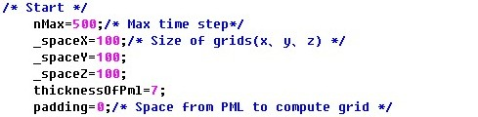
b) Set excitation source. Firstly, we set the excitation source in central of the computational space, which is (50, 50, 50), excitation port is parallel to z-axis. Source type is 0--point source, and wave form is 3-- Derivative Gaussian pulse, amplitude is 1 V, delay is t0, 150 time steps, pulse width is 120 time steps.
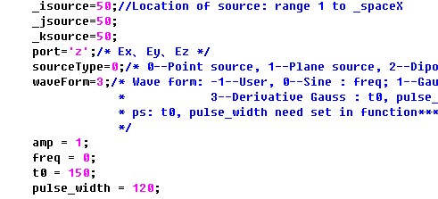
c) Store the field data. In this example, we just store one plane data--xoy plane in z=50, from time step 1 to 500, interval is 1 time step, so we set “save_plane_amount” to 1, and others will done automatically.

3.1.3 Compile and run
Compile the MedFDTD, open mpich2, set number of CPU, load MedFDTD, then run.

3.1.4 Results
The Ex results at time step 150 is shown in figure 3.1.
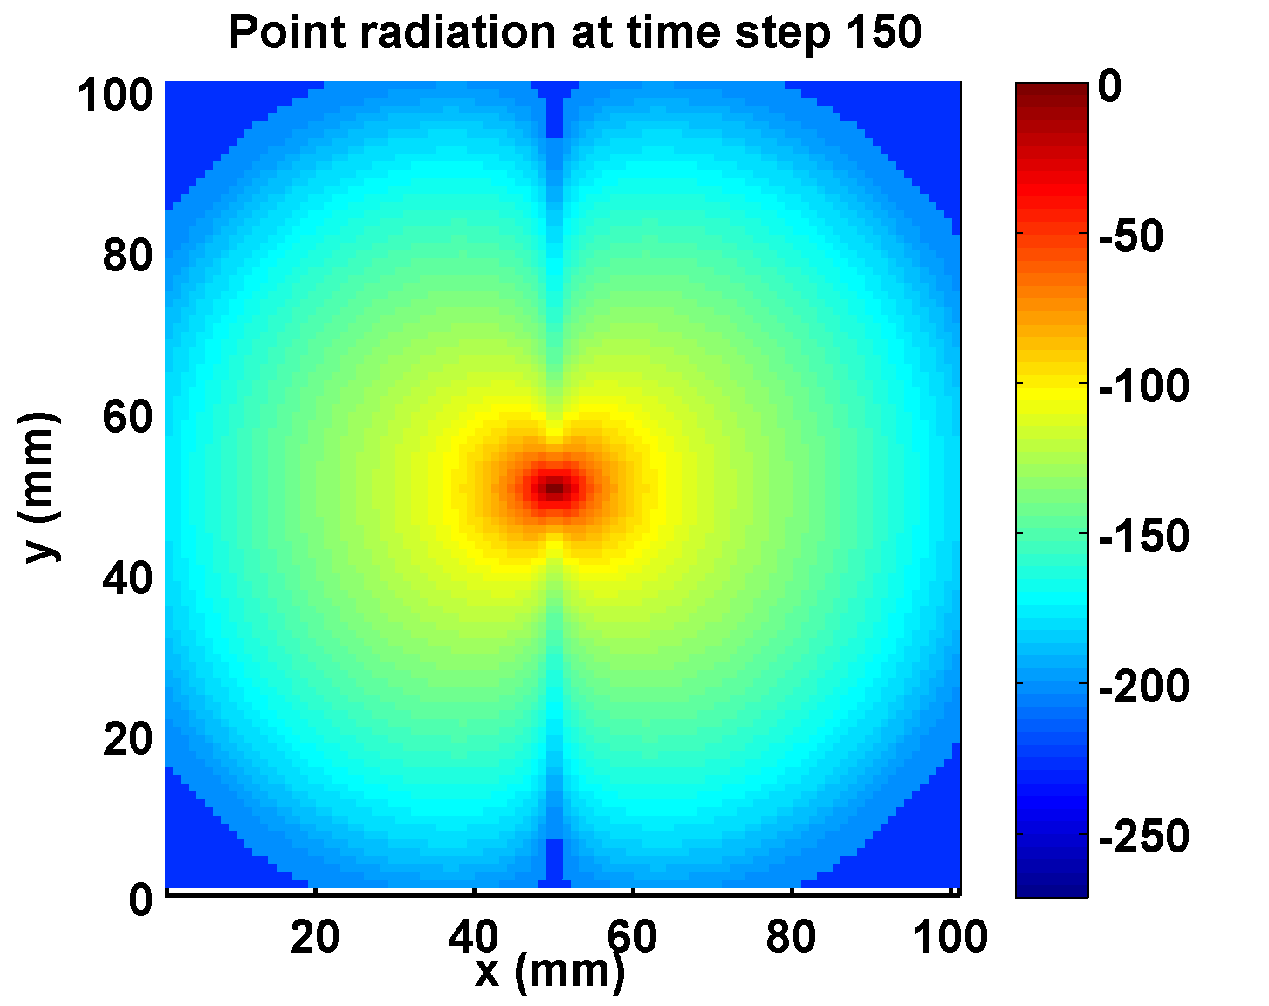
Figure 3.1

3.2 Dipole antenna: simulation and parameters calculation
3.2.1 Set data path
Go to “3D_FDTD_DEFINES.h”, modify the codes as following step:
a) Set “isNewPorj” to 1;
b) Set ”path_proj[128] = “D:\\”;”, “proj_name[64] = “antenna”;”, “path_log[128] = “D:\\logs\\”;”;
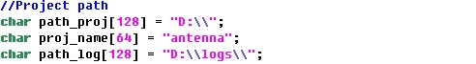
c) Set “path_save[128] = “D:\\”;”;
d) Set length of cells to 0.001 meter;
e) In antenna simulation, the radiation power calculation block have been used, and the SAR calculation block haven’t been used, so the following lines are commented.

3.2.2 Create a new project
Go to “MedFDTD_Main.cpp”, find function “newProject”, and modify the codes as following step:
a) Set the number of iterations to 2000 time steps, and the size of computational space is 100 × 100 × 100 cells, absorbing boundary is PML, with thickness of 7 cells.
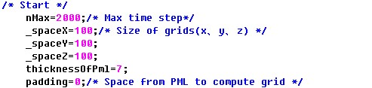
b) Set excitation source in central of the computational space, which is (50, 50, 50), excitation port is parallel to z-axis. Source type is 0--point source, and wave form is 0--Sine, amplitude is 1V, frequency is 1.8GHz.
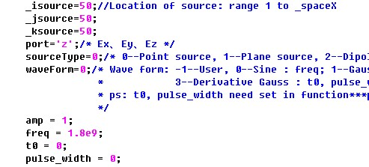
c) Store the field data. In this example, we store three plane data, which through the excitation point--xoy plane in z=50, yoz plane in x=50 and xoz plane in y=50, from time step 1 to 500, interval is 1 time step, so we set “save_plane_amount” to 3, and others will done automatically.
d) Set antenna. Find function “buildObject” in the above of “newProject”, creat an antenna by define struct _DIPOLE_ANTENNA, set the Antenna polarization direction to 3--z-axis, and feed point is the excitation point in b), impedance is 73.1Ohm, oscillator length is 39mm, then create this antenna by function “creatDipoleAntenna”.
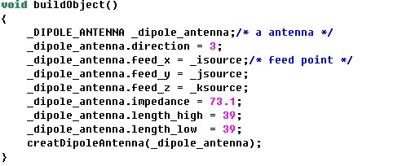
3.2.3 Compile and run
Compile the MedFDTD, open mpich2, set number of CPU, load MedFDTD, then run.

3.2.4 Results
User can see a averaged radiation power in the end of the output, and instantaneous power is stored in “poynting.txt” under the save path.
The Ex results at time step 120 is shown in figure 3.2.
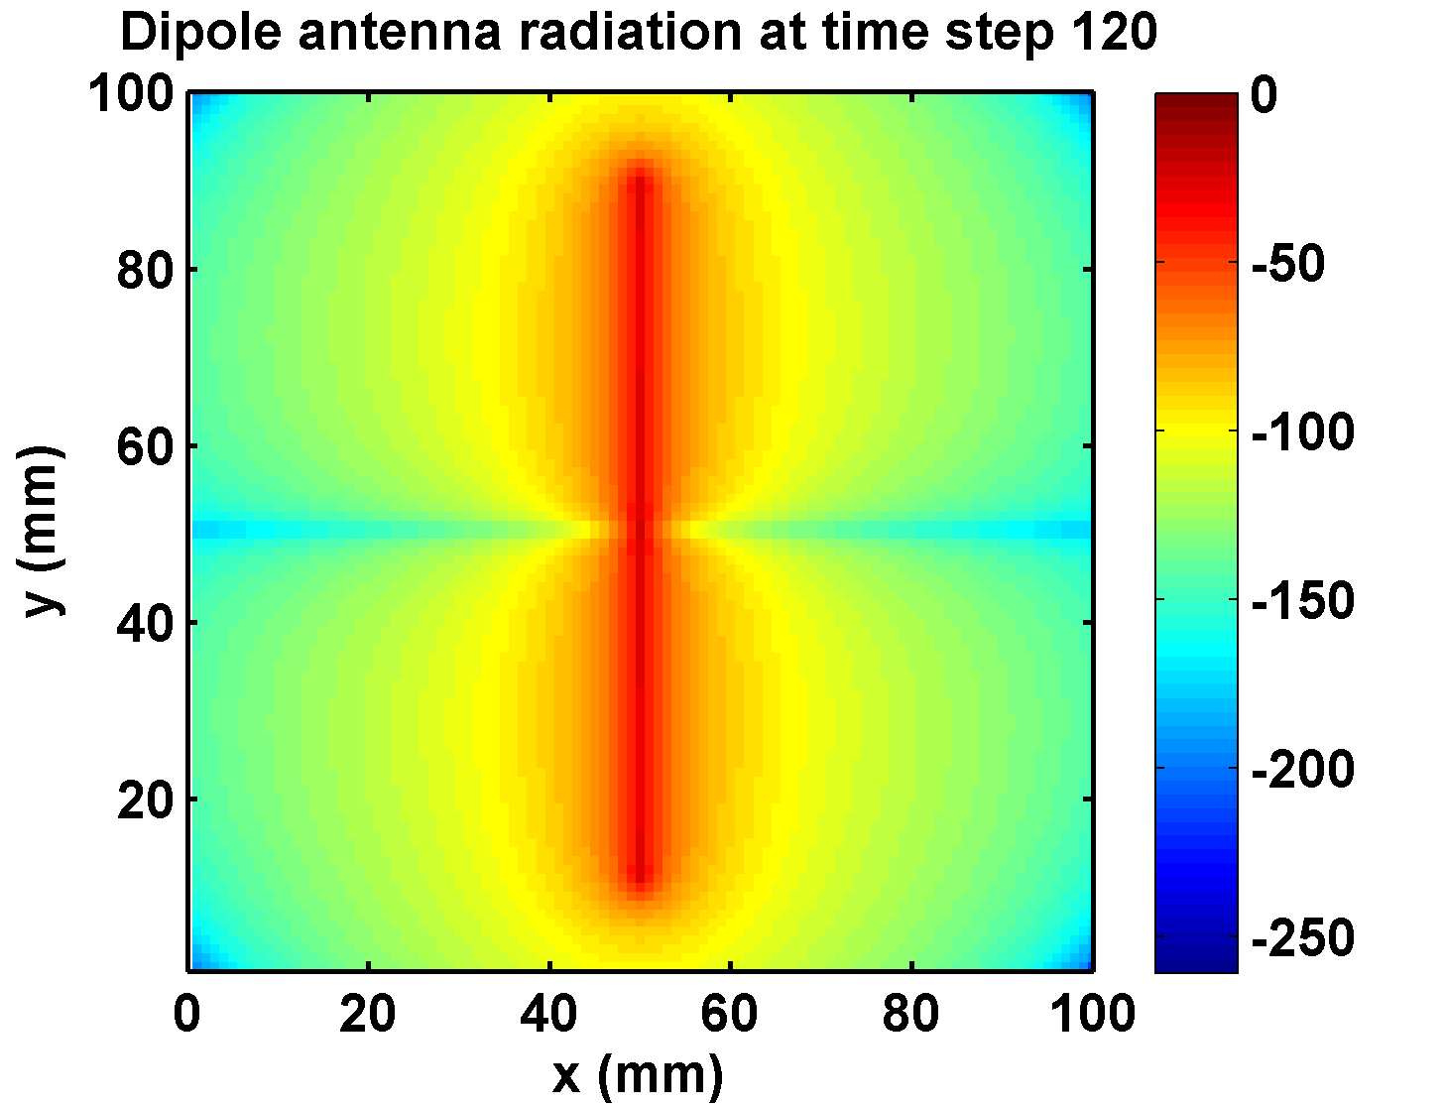
Figure 3.2

3.3 SAR calculation: a fat exposure to antenna
3.3.1 Set data path
Go to “3D_FDTD_DEFINES.h”, modify the codes as following step:
a) Set “isNewPorj” to 1;
b) Set ”path_proj[128] = “D:\\”;”, “proj_name[64] = “fat”;”, “path_log[128] = “D:\\logs\\”;”;
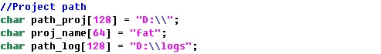
c) Set “path_save[128] = “D:\\”;”;
d) Set length of cells to 0.001 meter;
e) In this example, the radiation power calculation block haven’t been used, and the SAR calculation block have been used, so the following lines are commented.

3.3.2 Create a new project
Go to “MedFDTD_Main.cpp”, find function “newProject”, and modify the codes as following step:
a) Set the number of iterations to 2000 time steps, and the size of computational space is 100 × 100 × 100 cells, absorbing boundary is PML, with thickness of 7 cells.
b) Set excitation source in central of the computational space, which is (50, 50, 50), excitation port is parallel to z-axis. Source type is 0--point source, and wave form is 0--Sine, amplitude is 1V, frequency is 1.8GHz.
c) Store the field data and sar data. In this example, we needn’t store field data, so we set “save_plane_amount = 0”. To calculate mass averaged sar, find “#ifdef _SAR”, set “XgSAR = 10”, that mean the software will calculate 10g mass averaged sar in post-process, and local sar of all plane will be calculated and stored.
d) Set antenna as described in 3.2.2 d).
e) Create a fat. In this example, we need a fat to absorb the radtation, so call function “buildCuboid”, create a rectangular fat start at (30, 55, 10), and edge length (40, 30, 80), relative permittivity is 5.3, conductivity is 0.08V/m, density is 0.92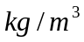 by code “buildCuboid(30, 55, 10, 40, 30, 80, 5.3, 0.08, 0.92)”, because of the total mass less than 10g, we change the density to 920, this just in order to reduce calculation scale.
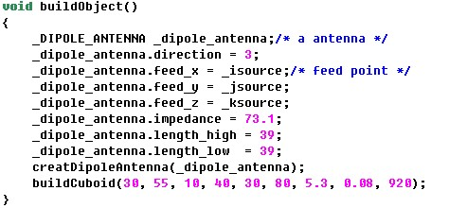

3.3.3 Compile and run
Compile the MedFDTD, open mpich2, set number of CPU, load MedFDTD, then run.

3.3.4 Results
The local sar data and mass averaged sar data are stored in file “localsar.txt” and “MassAveragedSAR.txt”, file format is described in 4.2 and 4.3.
The mass averaged sar data in z=50 xoy plane is shown in figure 3.3.
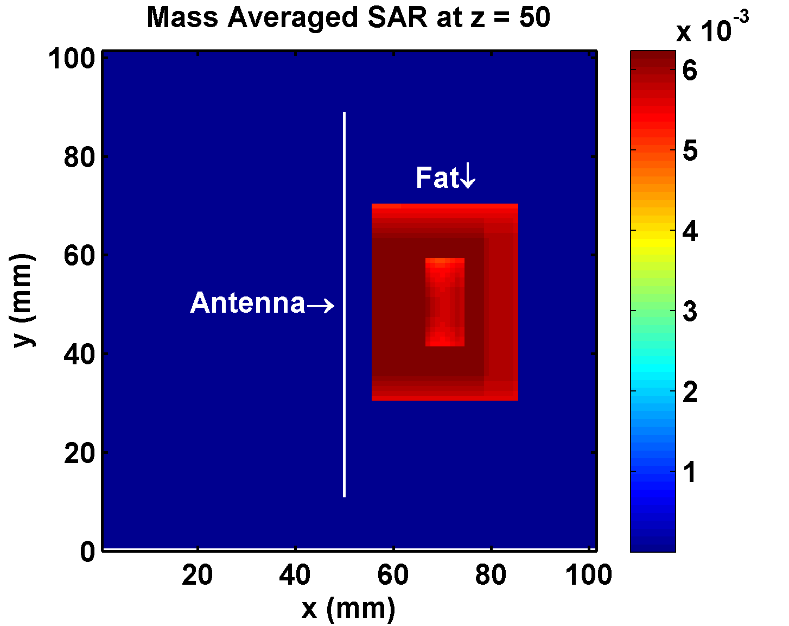
Figure 3.3

4. File format

4.1 User defined source
The format of user defined source is as following.
Number of rows
Voltage | Row
Voltage | Row
… | …

4.2 Store data and model data
The files format, such as field data files (ex, hx, etc.), model data files (epsilon, sigma, rho), local SAR data, are written as following.

Field data:
Xoy plane:
For Tstart to Tend
For Ystart to Yend
For Xstart to Xend
{…}
End
fprintf(fp, “\n”);
End
End

Yoz plane:
For Tstart to Tend
For Zstart to Zend
For Ystart to Yend
{…}
End
fprintf(fp, “\n”);
End
End

Xoz plane:
For Tstart to Tend
For Zstart to Zend
For Xstart to Xend
{…}
End
fprintf(fp, “\n”);
End
End

Model data:
For Zstart to Zend
For Ystart to Yend
For Xstart to Xend
{…}
End
fprintf(fp, “\n”);
End
End

Local sar data:
Xoy plane:
For Ystart to Yend
For Xstart to Xend
{…}
End
fprintf(fp, “\n”);
End

Yoz plane:
For Zstart to Zend
For Ystart to Yend
{…}
End
fprintf(fp, “\n”);
End

Xoz plane:
For Zstart to Zend
For Xstart to Xend
{…}
End
fprintf(fp, “\n”);
End

4.3 Mass averaged SAR
x y z sar
x y z sar
…

5. Parameters
“3D_FDTD_DEFINES.H”:
isNewPorj: create a new project file when isNewProj = 1;
path_proj: path of project files;
path_log: path of log files;
path_SRC: path of source files;
path_save: path of store field files;
path_data: path of model files;
data_name_eps: permittivity data file name;
data_name_sigma: conductivity data file name;
data_name_rho: density data file name;
LENGTH_OF_CELL: length of cell;
_POYNTING: define this parameters to compile radiation power calculation block;
_SAR: define this parameters to compile SAR calculation block;

“Med_FDTD.cpp”:
nMax: max time step of iterations;
_spaceX: length of computational space in x direction;
_spaceY: length of computational space in y direction;
_spaceZ: length of computational space in z direction;
thicknessOfPml: thickness of pml;
padding: vacuum around the compulational space;
_isource: coordinate of excitation source point in x direction;
_jsource: coordinate of excitation source point in y direction;
_ksource: coordinate of excitation source point in z direction;
port: polarization direction of exciation source
sourceType: type of excitation source, include point source and plane wave;
waveForm: waveform of the excitation source;
amp: amplitude of the excitation source;
freq: frequency of the excitation source;
t0: delay of Gaussian excitation source;
pulse_width: pulse width of Gaussian excitation source;
save_plane_amount: amount of store field plane;
XgSAR: require mass in mass averaged SAR calculation;

Available model function (used in function “buildObject”)
buildWire: set cell in a line;
buildPlane: set cell in a plane;
buildCuboid: set cell in a cuboid;
creatDipoleAntenna: create a dipole antenna defined by user;

